Avon City Council Meeting
September 6, 2023
Mayor Kevin Tjeerdsma called the meeting to order at 7:00 p.m. with Alderman Dodge, Muller. Petrik and Berndt answering roll call. Also, present finance officer Tina Gramkow, city maintenance Joe Paulsen, Brad Voigt
All present recited the Pledge of Allegiance.
Moved by Muller, second by Petrik to approve the agenda with adding August 16th minutes, 2023-02 Resolution Water Rates & Colored printer. All voting aye. Motion carried.
Moved by Muller, second by Berndt to approve the minutes of the August 7th & August 16. All voting aye. Motion carried
Moved by Berndt, second by Dodge to approve the claims with change to Ron’s Market. All voting aye. Motion carried.
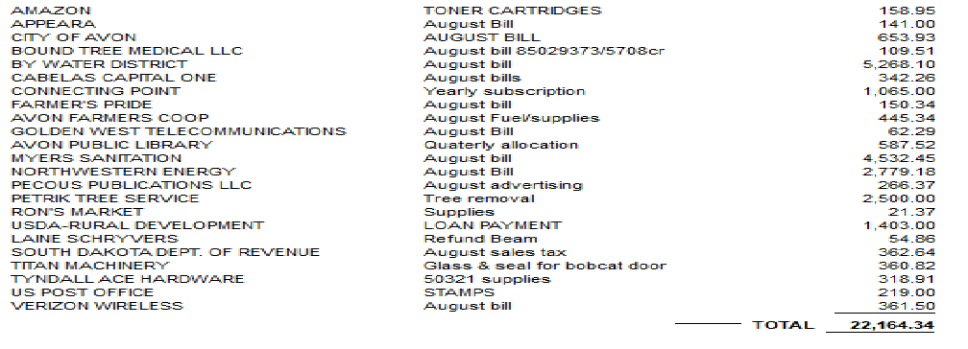
April payroll: Mayor/council, $1000.00; Library $1,371.34; Finance Office $3,336.25; Street Department $1,882.92; Water Department $1,903.91; Sewer Department $1,878.32; Police $1,873.42; Swimming Pool $2,237.51; SDRS, $2,238.26; Health Pool of SD, $4,028.10; AFLAC, $172.38; Beam Dental/Vision, $248.99; IRS, $2,605.03
Moved by Dodger second by Petrik to approve the receipts. All voting aye. Motion carried.
Water sales, $15,187.34; Sewer sales, $5,023.49; Garbage receipts, $5,022.66; Ambulance, $4,132.29; Dog Tags, $25.00. Building Permits, $90.00; Property Tax, $1,433.22; Special Assessments, $280.44; Sales Tax, $4,881.19; 5% Motor Vehicle $652.79; Recreation Fees, $1,301.48; Pasture Rental $2,480.00; other fees, $1,400.50
Brad Voigt asked on status of water shut off valve by property. Rollie has agreed to do when has time.
Mike Boyle submitted letter regarding garbage charge as did not have can. Motion by Petrik, second by Berndt to not charge for next 3 months.
Committee reports:
Library: Financial report given

Streets: none

Recreation: none

Dump: None

OLD BUSINESS
Weber Drainage, Rollie to place drainage line
Nuisance Property turned over to attorney
Awning tabled, checking to see if shop class would be interested
NEW BUSINESS
17 Delinquent Notice Sent/3 door hangers/1 shut off
Police Officer Report None
First Reading 2024 Budget Ordinance
2021 & 2022 Audit Report
Motion by Petrik, second by Muller to not replace pool cover. All voting Aye. Motion carried
Motion by Muller, second by Dodge to surplus colored printer & fax machine. All voting Aye, Motion carried.
Motion by Berndt, second by Dodge to purchase new Laser Printer, All voting Aye. Motion carried.
Motion by Dodge, second by Petrik to accept bid for 1000-ton crushed concrete from Schultz Redi-Mix LLC at $10.50 per ton with them loading and hauling as it was only bid received.
No Propane Bids received
Motion by Petrik second by Muller to accept 2023-02 Resolution Water Rates as was not published last month when approved. All voting Aye, Motion carried
RESOLUTION 2023-002
A RESOLUTION AMENDING ORIDINANCE FOR 333
WHENEAS, it is necessary to amend Ordinance No 333 water, sewer, and garbage rates because of increase from vendors and annual increase.
BE IT ORDAINED BY THE CITY OF AVON, BON HOMME COUNTY, SOUTH DAKOTA
Section 1: Beginning September 1, 2023 all utility rentals in the City of Avon, South Dakota, shall be as follows:
For Water Only:
Minimum Consumption Charge
0 – 1000 gallons………………………………… $21.12 per additional 1,000 gallons
1001 – 10,000 gallons…………………………. $27.81 per additional 1,000 gallons
10,001 – 15,000 gallons ……………………... $28.33 per additional 1,000 gallons
15,001 – 20,000 gallons ……………………... $28.84 per additional 1,000 gallons
20,001 and above ……………………………... $10.42 per additional 1,000 gallons
The surcharge for water will remain the same at $3.30 per business/residence no matter how much water usage.
The sewer charge will be $15.71 for each business/residence no matter how much water usage.
The surcharge for sewer will remain the same at $2.70 per business/residence no matter how much water usage.
Section 2: Any resident who resides within the city limits and is hooked up to city water and sewer is required to have and pay the municipal garbage collection service. The city will provide municipal garbage collection service to all households using the municipal water service within the municipal city limit of Avon, South Dakota, and the monthly charge for said services shall be as follows:

Number of residents | Current – Rate
1 | $21.06 plus $1.31 tax or $22.36
2 | $22.30 plus $1.38 tax or $23.69
3 and 4 | $23.20 plus $1.44 tax or $24.64
5 and 6 | $25.38 plus $1.57 tax or $26.95
7 | $29.40 plus $1.82 tax or $31.23
8 | $34.58 plus $2.14 tax or $36.72

Section 3: Owner responsibility for payment of water/sewer and garbage bill. The owner of any property where the city services are supplied by the City of Avon will be held responsible for the payment of all City bills. When a property is rented, the new renter is required to make a $100.00 deposit to the City. At which time the occupant leaves any amount due over the deposit amount is passed on to the property owner. The property owner will also receive notice when an account is not being paid.
Section 4: Once an account is two months delinquent, it will be terminated on the 21st of the month if payment in full is not received by that date, no exceptions. Thereafter a One Hundred Dollar $100.00) reconnect fee shall be charged. For those customers who want water service terminated to avoid minimum water/sewer charges a fee of Twenty-five dollars ($25.00) to resume service shall be assessed.
Section 5: A meter shall be provided by the city to each dwelling. If the meter is damaged or destroyed due to the fault of the owner/renter, the owner/renter shall then be responsible for the cost of replacing said meter. If a customer chooses to have a different meter placed in an existing dwelling for reasons other than damage to the meter, the customer is responsible for the cost of the new meter. For a new hoop up there is a $100.00 deposit, which is returned upon discontinuing the service if the bill is in good standing.
Section 6: Annually the water, sewer, and garbage rates will be increased by 3% per rate. This increase in rates will take effect on September 1st of each year.
Section 7: A Thirty Dollar ($30.00) charge for all returned checks given to the city shall hereafter be charged
Section 8 From now forward any change in fees will be established by council resolution.
Section 9: All ordinances or parts thereof in conflict herewith are specifically repealed to the extent so changed or modified herein.
__________________________________
Kevin Tjeerdsma – Mayor
___________________________________
Tina Gramkow – Finance Office

First Reading: 8/7/2023 (SEAL)
Pass and approved: 08/7/2023
Published:
Effective: 09/01/2023

8:41 Motion by Berndt, second by Petrik to go into Executive Session
8:50 pm came out of Executive Session
8:58 Motion by Dodge, second by Petrik to Adjourn.
Special Meeting September 13 at 6:00 pm
Next regular meeting October 2, 2023 at 7:00 pm
Dated September 6, 2023
Attest____________________________
Kevin Tjeerdsma, Mayor

Attest___________________________
Tina Gramkow, Finance Officer

